**Lab 1**

**Q1. Setup the spring boot application and print the hello world message**

Step 1: Go to Spring initializer <https://start.spring.io/>.

Step 2: Configure the project.

Step 3: Add dependencies which are required for the project and download it.

Step 4: Import project to Eclipse, in Eclipse go to **File> Import > Existing Maven Project**

Browse to the folder and import it.

Step 5: Build and Run the project.

Step 6: Verify the application by going to <http://localhost:8080/>

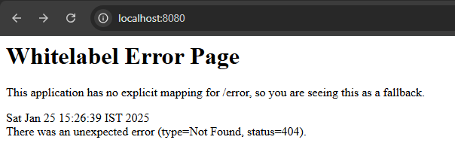

Whitelable Error Page is coming that means that the application has started successfully.

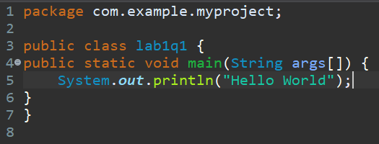

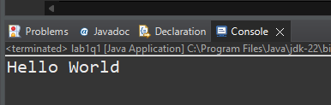

**Q2. Setup the spring boot application with hello world message in separate package names collector**

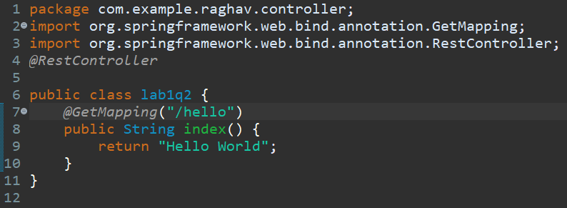

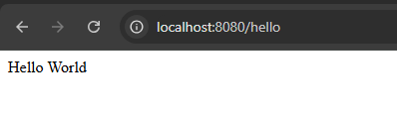

**Q3. Test the above application in POSTMAN**

